**DAILY ASSESSMENT FORMAT**

|  |  |  |  |
| --- | --- | --- | --- |
| **Date:** | **22 June 2020** | **Name:** | **Rohan Shetty** |
| **Course:** | **C++ programming** | **USN:** | **4AL17EC079** |
| **Topic:** | **Module 1: Basic concepts** | **Semester & Section:** | **6th & B** |
| **GitHub Repository:** | **rohan-shetty-online-courses** |  |  |

**Comments**

**Comments** are explanatory statements that you can include in the C++ code to explain what the code is doing.   
The compiler ignores everything that appears in the comment, so none of that information shows in the result.   
  
A comment beginning with **two slashes (//)**is called a single-line comment. The slashes tell the compiler to ignore everything that follows, until the end of the line.   
  
**For example:**

#include <iostream>  
using namespace std;  
  
int main()  
{  
**// prints "Hello world"**  
cout << "Hello world!";  
return 0;  
}

**Multi-Line Comments**

Comments that require multiple lines begin with **/\*** and end with **\*/**  
You can place them on the same line or insert one or more lines between them.

/* This is a comment */  
  
/* C++ comments can  
span multiple lines  
*/

**Using Comments**

Comments can be written anywhere, and can be repeated any number of times throughout the code.  
Within a comment marked with /* and */, // characters have no special meaning, and vice versa. This allows you to "nest" one comment type within the other.

/* Comment out printing of Hello world!  
  
cout << "Hello world!"; // prints Hello world!  
  
*/

**Variables**

Creating a **variable**reserves a memory location, or a space in memory for storing values. The compiler requires that you provide a **data type** for each variable you declare.   
C++ offer a rich assortment of built-in as well as user defined **data types**.  
  
**Integer**, a built-in type, represents a whole number value. Define integer using the keyword **int**.  
C++ requires that you specify the **type**and the **identifier**for each variable defined.An **identifier**is a name for a variable, function, class, module, or any other user-defined item. An identifier starts with a letter (A-Z or a-z) or an underscore (_), followed by additional letters, underscores, and digits (0 to 9).  
For example, define a variable called **myVariable**that can hold **integer**values as follows:**int** myVariable = 10;

**Arithmetic Operators**

C++ supports these arithmetic operators. 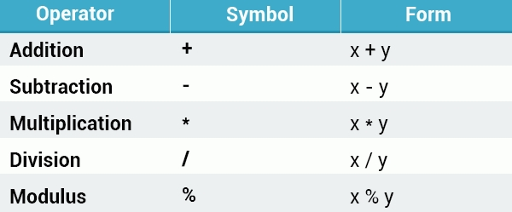

**Operator Precedence**

Operator **precedence**determines the grouping of terms in an expression, which affects how an expression is evaluated. Certain operators take higher precedence over others; for example, the multiplication operator has higher precedence over the addition operator.  
**For example:**

int x = 5+2*2;  
cout << x;  
// Outputs **9**

The program above evaluates 2*2 first, and then adds the result to 5.  
  
As in mathematics, using **parentheses**alters operator precedence.

int x = (5 + 2) *2;  
cout << x;  
  
// Outputs 14

**Assignment Operators**

The simple **assignment**operator (=) assigns the right side to the left side.   
  
C++ provides shorthand operators that have the capability of performing an operation and an assignment at the same time.   
**For example:**int x = 10;  
**x += 4**; // equivalent to x = x + 4  
**x -= 5**; // equivalent to x = x - 5

The same shorthand syntax applies to the multiplication, division, and modulus operators.x *= 3; // equivalent to x = x * 3  
x /= 2; // equivalent to x = x / 2  
x %= 4; // equivalent to x = x % 4

**Increment Operator**

The **increment**operator is used to increase an integer's value by one, and is a commonly used C++ operator.  
**x++;** //equivalent to x = x + 1

**Decision Making**

The **if** statement is used to execute some code if a condition is true.  
  
**Syntax:if** (condition) {  
statements  
}  
The **condition**specifies which expression is to be evaluated. If the condition is true, the statements in the curly brackets are executed.

# Relational Operators

Additional relational operators: 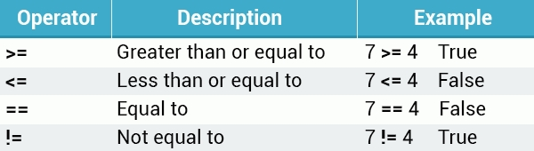  
**Example:**

if (**10 == 10**) {  
cout << "Yes";  
}  
  
// Outputs "Yes"

# The else Statement

In all previous examples only one statement was used inside the if/else statement, but you may include as many statements as you want.  
  
**For example:**

int mark = 90;  
  
if (mark < 50) {  
cout << "You failed." << endl;  
cout << "Sorry" << endl;  
}  
else {  
cout << "Congratulations!" << endl;  
cout << "You passed." << endl;  
cout << "You are awesome!" << endl;  
}  
  
/* Outputs  
Congratulations!  
You passed.  
You are awesome!  
*/

# Nested if else Statements

C++ provides the option of nesting an unlimited number of if/else statements.  
**For example:**

int age = 18;  
if (age > 14) {  
if(age >= 18) {  
cout << "Adult";  
}  
else {  
cout << "Teenager";  
}  
}  
else {  
if (age > 0) {  
cout << "Child";  
}  
else {  
cout << "Something's wrong";  
}  
}